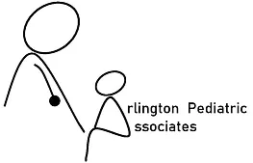
HIPAA Compliance Patient Consent Form
Our Notice of Privacy Practices provides information about how we may use or disclose protected health information.
The notice contains a patient’s rights section describing your rights under the law. You ascertain that by your signature that you have reviewed our notice before signing this consent.
The terms of the notice may change, if so, you will be notified at your next visit to update your signature/date.
You have the right to restrict how your protected health information is used and disclosed for treatment, payment, or healthcare operations. The HIPAA (Health Insurance Portability and Accountability Act of 1996) law allows for the use of information of treatment, payment, or healthcare operations.
By signing this form, you consent to our use and disclosure of your protected information and potentially anonymous usage in a publication. You have the right to revoke this consent in writing, signed by you. However, such a revocation will not be retroactive.
By signing this form, I understand that:
- Protected health information may be disclosed or used for treatment, payment, or healthcare operations.
- The practice reserves the right to change the privacy policy as allowed by law.
- The practice has the right to restrict the use of the information but the practice does not have to agree to those restrictions.
- The patient has the right to revoke this consent in writing at any time and full disclosures will then cease.
- The practice may condition receipt of treatment upon execution of this consent.
May we phone, email, or send a text to you to confirm appointments? Yes No
May we leave a message on your answering machine at home or on Yes No
your cell phone?

May we discuss your medical condition with any member of your family? Yes No

If yes, please name the members allowed:

This consent was signed by:

Signature: Date:

